CAR INSURANCE

create database 1BM21CS107_Insurance;

use 1BM21CS107_Insurance;

create table person

(

driver_id varchar(20) primary key,

name varchar(30) not null,

address varchar(50) not null

);

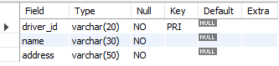

create table car

(

reg_num int primary key,

model varchar(50) not null,

year int not null

);

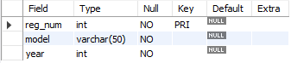

create table owns

(

driver_id varchar(50),

reg_num int,

primary key(driver_id,reg_num),

FOREIGN KEY (driver_id) references person(driver_id),

FOREIGN KEY (reg_num) REFERENCES car(reg_num)

);

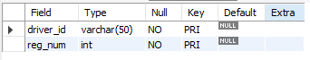

create table accident

(

report_num int primary key,

accident_date date not null,

location varchar(50) not null

);

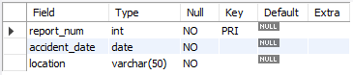

create table participated

(

driver_id varchar(50),

reg_num int,

report_num int,

damage_amount int not null,

primary key(driver_id,reg_num,report_num),

FOREIGN KEY (driver_id) references person(driver_id),

FOREIGN KEY (reg_num) REFERENCES car(reg_num),

FOREIGN KEY (report_num) REFERENCES accident(report_num)

);

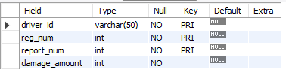

insert into person values

(

'A01',

'Mike',

'Central Park, New York'

);

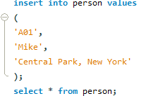

desc person;

insert into person

values("a01","sanjit","mg road");

insert into person

values("a02","sanjay","rajajinagar");

insert into person

values("a03","sharon","srinivasnagar");

insert into person

values("a04","sid","mg road");

insert into person

values("a05","Dhruv","jayanagar");

select * from person;

desc car;

insert into car

values('ka001',"volks",1986);

insert into car

values("ka002","honda",1989);

insert into car

values("ka003","mercedes",1996);

insert into car

values("ka004","audi",1979);

insert into car

values("ka005","toyota",1973);

select * from car;

desc owns;

insert into owns

values("a01","ka001");

insert into owns

values("a03","ka004");

insert into owns

values("a02","ka003");

insert into owns

values("a05","ka005");

insert into owns

values("a04","ka002");

select * from owns;

insert into accident

values(11,'2003-01-1',"mysore road");

insert into accident

values(12,'1990-01-1',"mysore road");

insert into accident

values(13,'2003-01-2',"kanakpur road");

insert into accident

values(14,'2005-05-1',"south end circle");

insert into accident

values(15,'2012-08-3',"bull temple road");

select * from accident;

select count(distinct driver_id) CNT

from participated a,accident b

where a.report_num=b.report_num and b.accident_date like '__03%';

insert into participated

values("a01","ka001",11,11000);

insert into participated

values("a02","ka002",12,21000);

insert into participated

values("a03","ka003",13,33000);

insert into participated

values("a04","ka004",14,49000);

insert into participated

values("a05","ka005",15,51000);

select * from participated ;

select * from car order by year asc;

select count(report_num)

from car c,participated p

where c.reg_num=p.reg_num

and c.model="honda";

select * from participated

order by damage_amount desc;

select avg(damage_amount) AVRG_MT

from participated;

delete from participated where damage_amount<(select t.amt from(select avg (damage_amount) as amt from participated) t);

select * from participated;

select name from participated p, person a

where p.driver_id=a.driver_id and damage_amount >(select t.amt from (select avg(damage_amount) as amt from participated )t);

select max(damage_amount) max_amt from participated ;